Wilson Financial Reports

Jason Schriner, Rachel Shaw, Mark White & Rachel Theis

12/12/2024

**Report #1: How many clients have been added in the past 6 months?**



**Description:** By generating this code it is possible to query the database to establish how many new clients they acquired in the past 6 months to determine if more advertising was needed.

**Report #2: What is the average amount of assets (in currency) for the entire client list?**



**Description:** This query would help Wilson Financial determine what is the best services to offer their clients and what their clients might be able to afford.

**Report #3: How many clients have a high number (more than 10 a month) of transactions?**

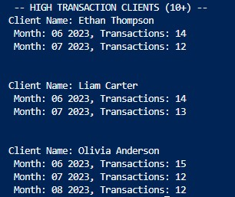

**Description:** This records search allows Wilson Financial to determine who if anyone regularly uses their services. This can guide decisions like adding offerings for frequent users

**Report #4: How many bills have been sent within the past 6 months?**



**Description:** This database query will help to determine if they are generating enough revenue and have enough clients to stay profitable.